Poker Database Written Report
By David Beauchamp
Project Overview/Final Application:
Github Repository: https://github.com/djbeauch-pixel/Applied-Database-Technologies---Final-Project
Original Poker Dataset (Zenodo, Kim J): https://zenodo.org/records/13997158
Before this course, I set out to create my own poker database and application, first by parsing through standard text files. I was unable to complete the parsing step to have clean data to work from. This exercise has allowed me to use very structured data, due to our friend Kim, to run analysis.
We started by designing a data schema and building a parser of PHHS files by reviewing other Kim J. sources and iterating with Claude as my technical collaborator upon analysis of the files, their patterns, fields and values. I then developed my database design and queries to get the most out of the data, with what I saw from some sample files I worked with manually on my computer and through my Jupyter Notebook via Python.
I spent some time tinkering with code, building/tearing down my MySQL database, which I chose for the relational nature of Poker (outlined more deeply in earlier sections), because going from folder to folder, site to site, revealed inconsistencies in formatting, contrary to my assumptions, and required me to uplevel and adjust my code.
Once in, I was able to use Streamlight, which is extremely effective at statistics, sorting and database visualizations and features. It was an easy baseline since my main goal was to serve the information to the people, our users, who will come to this site to learn more about the player pool and where they can choose the best games for their skill level.
The final application (not deployed, run locally) is a beautiful representation of what parsing through thousands of poker hands and utilizing a database can get you. Granted this data is from 2009 and play has adjusted over time, but this is a great baseline for dealing with PHHS files and scalable to run analysis for online play in the poker world today.
Each time I saw data from the pooled hands across stake/site it validated my premise in the beginning and too validated my ETL, schema, database design and implementation. There are clear signals of optimization at higher stakes, and variance and differing levels of play across sites. We have whittled our data down so it’s not simply every player but has conditions so a player needs to have 100 hands or more to qualify.
These features are coming from my initially designed SQL queries available in the Github Repo’s SQL folder as well as expanded features in my app.py file, pulling from my database via python code as well as built in libraries (ie. Pandas, mysqlconnector, etc): 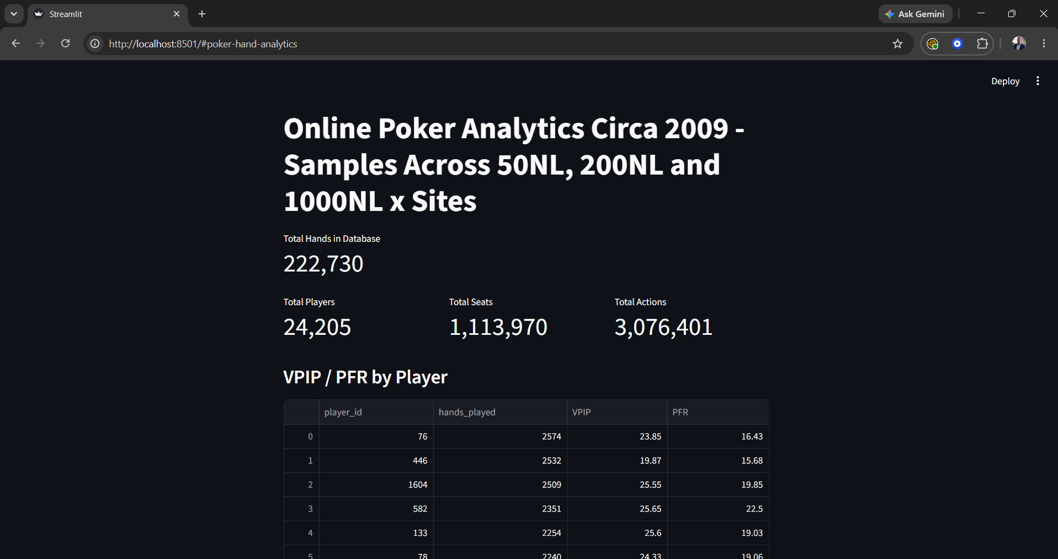
- First, we’re reviewing a few metrics from our database so we can assess what the data is that we’re dealing with (Metric Card format – V2. Could be a sleeker look with boxes
- Next, we’ll see a VPIP/PFR bucket by player ordered by most hands – while not ideal w/ player IDs, it gives users a view of the landscape.
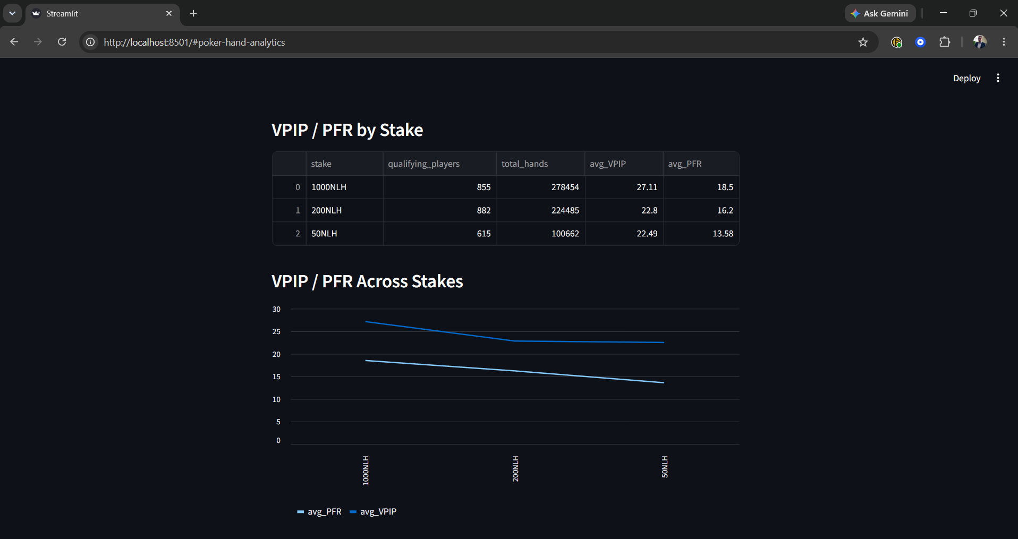
- Then we have our VPIP/PFR by stake, at a high-level glance, 3 levels, qualifying players only, their total hands, and average VPIP/PFR
- Then we’re showing our VPIP/PFR across these stakes in a graph to show the drop and level off in aggression as you go down stakes and plateau off between 200NL and 50NL.
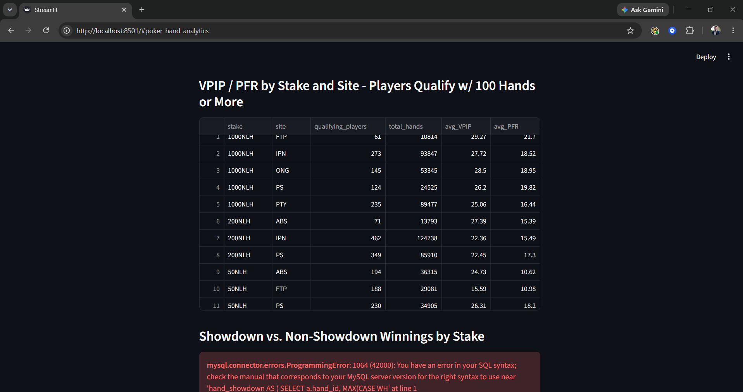
- Finally, you can see we added site data into the mix so you can see what each game looks like by site and stake level, and how soft or strong it is, as well as the corresponding data.
- 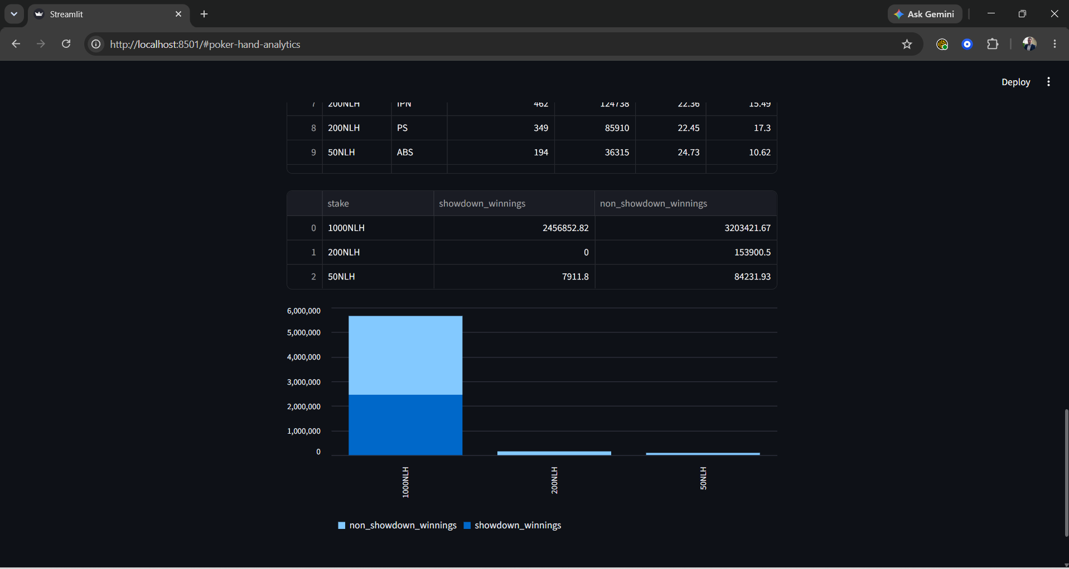
- [Still under construction] Couldn’t leave the money out of our analysis! The finishing touches.. the absolutely bewildering amount of money won overall at 1000NL and the impressive amount of money won before showdown – which means the player wins uncontested (skill play, aggression, bluffing, value bets).
- Caveats: There are clear errors here, as it’s impossible for 200NLH to have received $0 money at showdown over this large a sample size. Also, according to the graph, the 50 NLH players, have won over 10x before showdown than at showdown. As a domain expert this is nearly impossible, as you can see the 3.2:2.4 split at 1000NLH is much more indicative of reality, where good players are making 1:1 before showdown and during showdown. Winning at showdown is considered luck since there’s no more moves to be made at that point, but showdown win rate can also show where you’re losing, by overcalling, over folding, etc which could be implemented in a v2 of this app for our users.
Some final adjustments from Part 2, development and architecture to scalability and implementation:
- Added another table on parsed and uploaded files for resumability, reproducibility and data integrity. I wanted to ensure that I didn’t upload any duplicates in the current database, instead of deleting/resuming from scratch as I want this to be scalable for the future.
- player_ids and next_hand_id now come from a live query against the DB instead of hardcoded starting points
- loaded_files is a new small table acting as a ledger, so when I rerun the notebook with overlapping files_to_load, already-processed files get skipped instead of silently re-inserted under new IDs.
- The loaded_files insert happens inside the same per-file commit, so a crash mid-file won't mark it as loaded when it wasn't fully written.
- Site_hand_id data type was BIGINT NOT NULL but I ran into an error with a file/poker site that had R5-########-## as it’s format so I had to adjust my database construction to fit VARCHAR(50) instead (Site ONG pulled this error)
- Next we had issues with our 6th file download not recognizing “table” data so we’re going to use the same .get() method we used in our previous field with time_zone_abbreviation.
- Ran into tble_name exceeding the VARCHAR(50) in my final implementation, adjusted to VARCHAR(150);
- At ~115,000 hands I ran into a bad hand that broke the parser so I added a try/except keyerror exception handling so it doesn’t break over one bad hand and instead continue instead of stopping dead.
Upon completion of the 220k~ hands in my database, my h.stakes SQL query was having issues running so I consulted with Claude AI which said the system basically ran out of time since the computer is running millions of hand_players rows multiplied against however many qualifying players there are, per stake. Pre Claude AI, “That combinatorial explosion is almost certainly what caused MySQL to run out of memory or exceed a timeout and drop the connection — not a networking fluke.”
So I adjusted our query to make it more efficient, as Claude diagnosed, by removing the two joins on the hands and hand_player. Every qualifying player got cross-joined against every hand and hand_player row sharing that stake. The fix just deletes those two extra joins and the outer GROUP BY/aggregates run straight on player_stats itself, which already had everything needed.
My first SQL file is a list of simple sql queries to look at everything in each table and look at how many hands we have across stakes, which I would run each time I ran an import.
My first major SQL query is my player VPIP/PFR which is averaged across preflop play with a qualifier `HAVING COUNT` clause where the hand count is equal to or higher than 100, ordered by most hands played to show we’re filtering out outliers and prioritizing high hand volume.
We’re using roughly the same logic to get VPIP/PFR across site and stake. The issue is that we’re looking for player actions which isn’t at the site/stake level so we implemented aninner subquery to do the player-level work first. Compute each player’s own VPIP/PFR, apply the HAVING >= 100 filter per player, and only then hand a clean list of qualifying players up to the outer query. So the AVG(VPIP/PFR) is the average of individual players’ rates, each player counted once regardless of volume which demonstrates how the typical qualifying player behaves at that stake/site rather than how did all the hands at this stake/site play out in aggregate.
My last SQL query to show earnings at and before showdown (used in app.py) also relies on few nested subqueries. The innermost subquery, hs, works per hand. It checks wheather any caction reached the river (reached_river), and separately counts how many distinct players folded at any point in the hand (folded_count). I needed to highlight both before I could actually decide whether a hand went to showdown or not.
The middle layer, hr, joins that back to the hands table and makes the actual showdown call: a hand only counts as is_showdown = 1 if it reached the river AND at least two players never folded. I added that section condition since if you reach the river alone or if someone folds on or before the river it’s not really showdown.
The outer query then joins hf to hand_players to pull in actual winnings and sums them separately by stake depending on whether is_shodown is 1 or 0 giving us two totals, money won at showdown and without showdown. Please recall that our is_showdown logic is an inference from action patterns, not a field in the original data. I thought about parsing this out on the front end but ended up added it as a query. There are still adjustments I have to make to right size this.
Link to deployed app: {have not deployed}
Technical Summary
MAMP Server, MySQL Workbench for Database management and queries
Python/Jupyter Notebook and its built in modules for ETL, MYSQL connector, Streamlit for application development and hosting since we’re dealing with statistics/metrics and are just looking to display our database in a clean format with filtering options. I could see the need for more development on the app side to really build on each section.
I used AI as a technical collaborator in clarifying technical concepts, exception/error handling and refining sections of my parsing code and app development. I also used for exception handling to adjust my second SQL script after Part 2 because my database scaled up with millions of actions my code crashed and required me to troubleshoot.
Reflection:
Parsing was one of the most difficult parts. I leaned on Claude for my app development and parsing through PHHS since it was my first time doing both. There were errors I made assigning different/improper data types that while parsing and inserting data to the poker_database would cause errors to populate and cause me to go back and restart the database from scratch. It was a lot of trial/error but was extremely rewarding when I finally broke through the 5th wall and all my 225,000 hands were inserted across 225 files on my computer. I believe I have a more intuitive sense of how these technologies function and would be excited to build another database in the future, or deal with differently formatted poker hands or data in the future.
In the future I feel like there’s changes I can make to the application, it’s features and the datas it shows, but really this is the best work I could deliver and I would love your feedback on additions I could make!
As a domain expert, I had visions of what I wanted to build but my expectations were quickly tempered with the complex nature of dealing with the messiness of real world data. At the beginning of this course, I tried to parse my Hold’em 3 Manager hands which were .txt files with this format: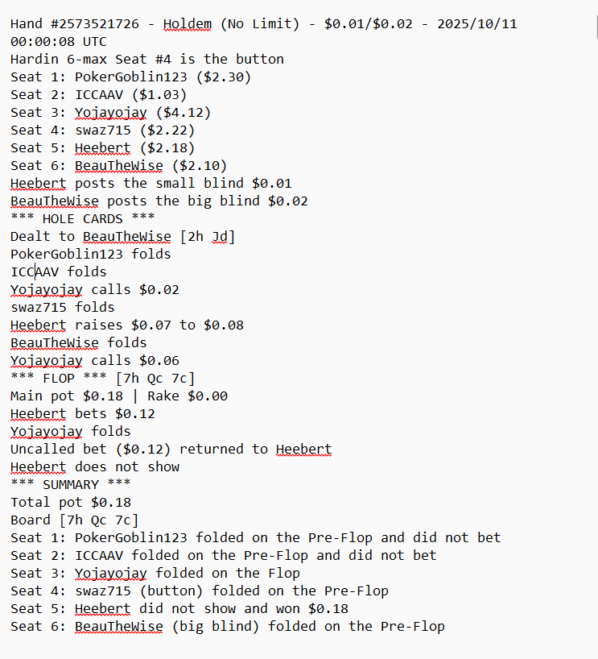
And I wasn’t able to parse it out, let alone upload all the data into a database and host that data on a webfacing application! I’m beyond proud of myself, but also understand there’s a lot of room for growth and feel I could continue to be a student for a long time before I ever truly master this art. I appreciated my time in the class, the knowledge it gave me and the hands on application and results I was able to develop because of it. Thank you – please don’t hesitate to reach out if you have questions or need clarification on any domain, sql, python, streamlit or conceptual choices I made.

References/Citations:
A Dataset of Poker Hand Histories (includes 21,605,687 uncorrupted no-limit hold'em hands scraped from HandHQ, July 1–23, 2009) [Data set]. Zenodo. https://zenodo.org/records/17136841
Kim, J. (2024). Poker Hand History File Format Specification. GitHub repository. https://github.com/uoftcprg/phh-std
Kim, J. (2024). Recording and Describing Poker Hands. In 2024 IEEE Conference on Games (CoG) (pp. 1–8). https://doi.org/10.1109/CoG60054.2024.10645611
phh-dataset [GitHub repository]. uoftcprg. https://github.com/uoftcprg/phh-dataset
Python Software Foundation. (n.d.). tomllib — Parse TOML files. Python 3 documentation. https://docs.python.org/3/library/tomllib.html
Oracle Corporation. (n.d.). MySQL Connector/Python Developer Guide. https://dev.mysql.com/doc/connector-python/en/
mysql-connector-python [Package]. PyPI. https://pypi.org/project/mysql-connector-python/
Streamlit Inc. (n.d.). Streamlit documentation. https://docs.streamlit.io/
Anthropic. (2026). Claude (Sonnet 5) [Large language model]. Used for debugging assistance, technical concept clarification, and code review during development. https://www.anthropic.com/claude

